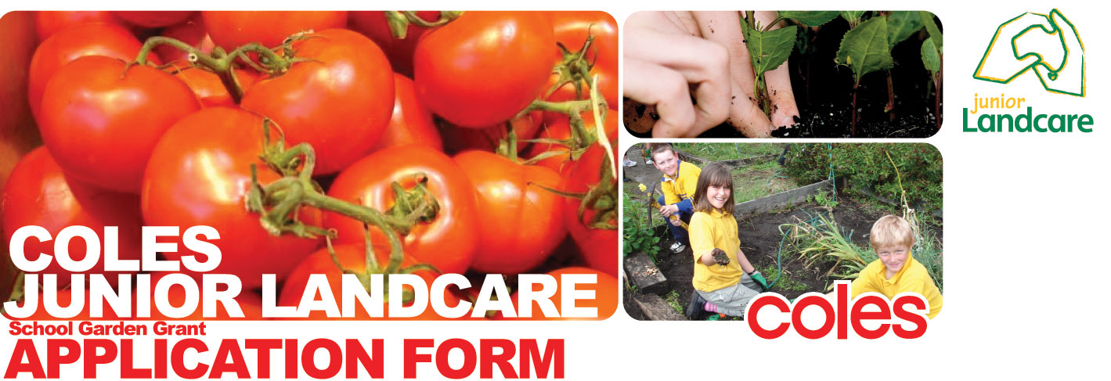


Name of school/youth group Type here
Project Title Type here

Contact Information

First Name: Type here
Surname:
Address:
Suburb/Town:
State:
Postcode:
Phone:
Email:

Name of nearest Coles store from school:

Distance to nearest Coles store from school: km (To calculate click here Coles Store Locator)

Catchment Management Authority Region: (To find your CMA click here CMA Finder)

ABN and GST

Does your school or group have an Australian Business Number (ABN): YES NO
If YES, please enter your ABN:
If your school/group does not have an ABN you must arrange for an affiliated group with an ABN to receive the funds on your behalf.
Sponsor Group Name:
Sponsor ABN:

Is your school registered for GST? YES NO

Project Details

Briefly describe your project

How does this project engage kids in on-ground environmental sustainability activities?

What environmental education outcomes will this project achieve and how does it link with school curriculum? (Please mention relevant curriculum subject/s or youth programs)

How will this project benefit the environment?

Has your school/group undertaken a School Environmental Management Plan (SEMP)? YES NO
If Yes, is this project part of your SEMP? YES NO

Does the project involve participation/collaboration from any of the following groups (tick those which apply)
Local Landcare Group
Catchment Management Authority or Natural Resource Management Organisation
Local Government
Other Schools
Local Business
Parents/the wider community/other community groups

What is the expected level of engagement with the selected group/s?

Number of students directly involved in project:

Number of other volunteers/community members directly involved in project:

How did you hear about the grant?

Budget

Please ensure that budget items correspond with the project description
Description of Item/Activity | A. Funding Requested (ex GST) | B. Your Contribution | Total (A+B)
Total

Previous Funding

Please indicate any previous junior landcare funding your group may have received within the past twelve months.

Please provide details of any overdue final reports owing to previous funding from Landcare Australia.

Endorsement

Please provide the name and contact details of a Landcare Group, CMA, Natural Resource Management Organisation (NRM) or Council representative who can endorse your project. It is essential to provide a project referee to confirm your project’s validity and ensure that the project is technically viable. If your application is successful this person will be contacted by Landcare to verify their support of your project.

Contact Name:
Phone Number:
Position:
Organisation:

NB: The contact person for a Landcare Group, CMA, or NRM can be found through the National Landcare Directory at www.landcareonline.com. A council representative can be found by contacting your local council and asking for the Environmental Officer/Bushcare Officer.

Declaration

By submitting this application form I Type name here, as a representative of Type group name here declare that:
  - The information given on this form is complete and correct, and appropriate group or organisation endorsement has been received to submit this application.
  - Funds will be used only for the project described on this application.
  - If successful, I agree to provide a written report within six months of the approval date, and any photos or video footage as part of the feedback process, for the use of LAL and Coles.
  - I consent to the release of project information in this application for promotional and evaluation purposes relevant to LAL and Coles.
  - I will seek permission from our group before submitting photographs for the use of LAL and Coles.

Send To

PLEASE HELP US BE MORE SUSTAINABLE

Every quarter we receive many grant application forms. Sometimes we receive two or three copies of the same application form which is not only a waste of paper but energy as well. Please help us be more sustainable. Our preferred method for receiving applications is:

Completing your application form ELECTRONICALLY and return via email to
grants@landcareaustralia.com.au


