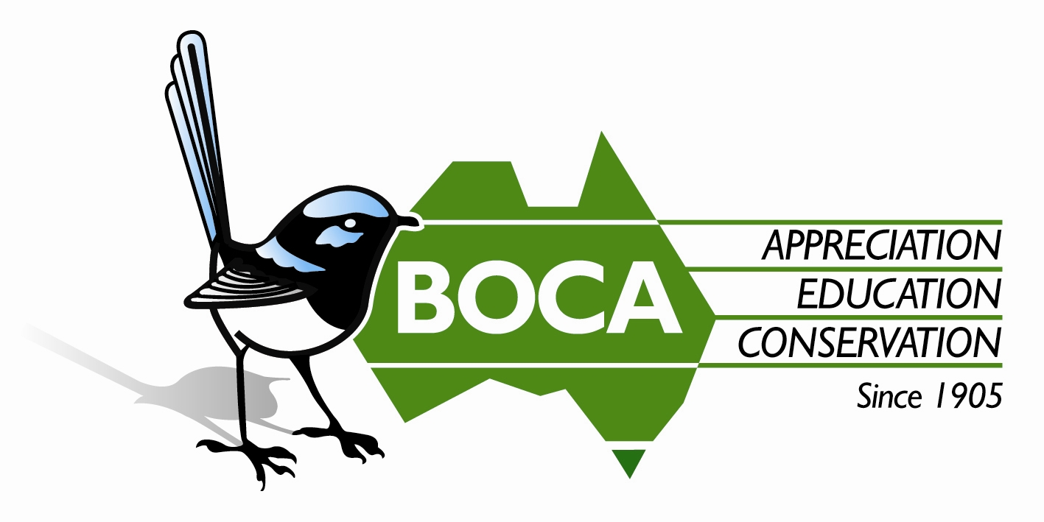
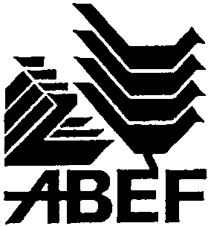

Bird Observation & Conservation Australia
ABN 24 005 068 842

183-185 Springvale Road (PO Box 185) Nunawading, Vic 3131 Australia
Tel: 03 9877 5342 Fax: 03 9894 4048
Email: admin@boca.org.au Web: www.boca.org.au

Guidelines for Making a Funding Application

These Guidelines are provided to assist in completing the attached Application form. Individual grant applications exceeding $5,000 are unlikely to be funded in full.

1. General

  - BOCA accepts applications for financial assistance for projects pertaining to Australian native birds and their habitats from any person or institution (whether public or private) to:

- undertake research and investigation, eg study of the needs of birds in their habitat;
- carry out voluntary conservation work, eg maintain, improve or extend habitat for birds;
- develop and execute education and information programs that educate the public to become more aware of birds and their habitat requirements;
- develop management plans or techniques.

1.2 Application forms, together with supporting information, must be received no later than 31 May each year, and the Application must be completed and signed by the person or persons responsible for implementing the project.

1.3 Funding will be allocated for a specific, clearly defined project that is planned for completion, under normal circumstances, within 12 months. Funding will not be given retrospectively, that is, to cover expenditure already incurred.

1.4 Projects will be assessed on merit, eg likelihood of completing within the time frame allowed, and on their contribution to the protection and conservation of Australian native birds and their habitats. The decision of the ∗Trustees is final and no correspondence will be entered into regarding the decision.

2. Nature of Project

2.1 In explaining how the aims of your project will be achieved, include details of any expert advice you have received, and from whom. Where tertiary-level research is involved, the name of your Supervisor and institutional address must be included.

2.2 Give examples of any experience you have with projects of a similar nature.

2.3 Indicate any assistance you may require to achieve the aims of the project and how you anticipate obtaining this assistance.

2.4 Comment on the potential impact of your project on the community. State how your project could be used to promote awareness of conservation. Give details of any in-kind contribution, including the involvement of volunteers.

2.5 You may like to include the name of someone who could act as a referee and who could provide information to the ∗Trustees on the validity and practicality of your project.

2.6 If funding is sought for a project involving habitat conservation or development:

(a) provide additional information regarding the status of the land (eg covered by Covenant, Land for Wildlife, park, roadside reserve); and
(b) provide a map or hand-drawn sketch showing the geographical location of the land concerned, indicating the distance from a local township or other points of reference. If the project is on private property, provide details of the area involved in the project relative to the whole of the property, as described in the Certificate of Title.

2.7 If funding is sought for a project involving planting, BOCA recommends the use of local indigenous species and if this is not the case, some explanation should be given. Information should also include plans for subsequent care and protection.

2.8 If the application is for a research project, supply appropriate supportive documentation such as ethics approval, banding permits and permits for work on public land (eg National Parks, State Forests, etc).

3. Relationship to any other Programs

The project for which funding is sought must be a discreet component, clearly identifiable, of any larger program. Explain the aims of the ongoing program and indicate what has so far been achieved and what stages still need to be completed, thus providing a frame of reference to explain the significance of this project and where it fits within the total plan.

4. Amount of funding sought

4.1 Provide an itemised list of costs.

4.2 Indicate whether costs given are general estimates or firm quotations. Attach copies of any quotations.

4.3 Total funds provided are inclusive of GST.

5. Property ownership

5.1 If the project is on private property, please provide a photocopy of the Certificate of Title and the relevant plan. If the Certificate of Title is not in the name of the applicant, a Statutory Declaration is required stating the relationship of the current owner to the applicant. Written approval of the owner is required.

5.2 If the applicant is not the sole owner of the property or if more than one property is involved, the consent of all parties concerned must accompany the application.

Further Information

Please contact Administration Manager at BOCA, if you require further assistance.

BOCA Conservation Grants are funded by Australian Bird Environment Foundation (ABEF)
which is the Conservation Trust of BOCA.
ABEF has its own Trustees and provides financial assistance under the rules of its own Trust Deed

Tel: 03 9877 5342 Fax: 03 9894 4048 Email: admin@boca.org.au
Web: www.boca.org.au

 Funding for BOCA Conservation Grants comes from the Australian Bird Environment Foundation (ABEF) which is administered by Trustees appointed by BOCA.

