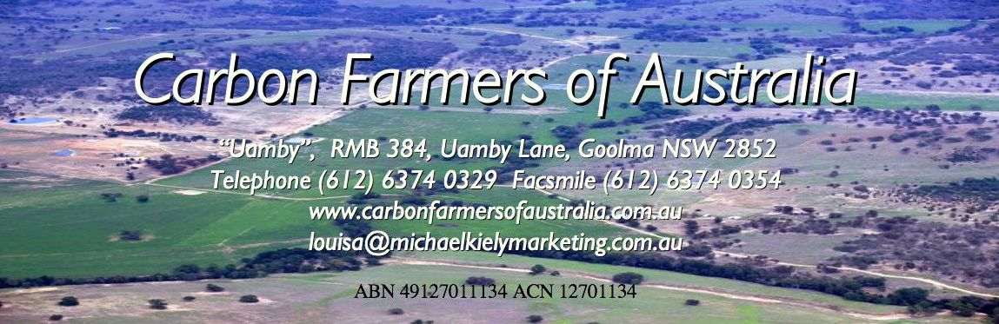
An Introduction to Carbon Farming and Trading Potentials

Session 1: Introduction 8.30AM

Introduce Carbon Farmers of Australia
Introduction to the Class Members – Participants introduce themselves
And what they would like to learn from the day.

Session 2: Soil Carbon – The Fundamentals

The Carbon Cycle and Climate Change

  - What is Carbon. What role does it play normally.
  - Why it is labelled a “Greenhouse Gas”.
  - Different views of Climate Change.
  - The Science of Climate Change:
  - Methane, nitrous oxide, water vapour and CO2e
  - Implications for Agriculture at Farm Scale

Soil Carbon Dynamics

  - How soil carbon is made
  - Photosynthesis Process – plants, trees, algae, cyanobacteria
  - Fractions – Soil Organic Carbon vs Soil Organic Matter
  - Soil Biology – Role of Microbial Community
  - Bio-Mimicry – Land Management that ‘mimics’ natural processes

MORNING TEA. 10.30- 11.00

Session 3: Soil Carbon – The Benefits

Benefits of Soil Carbon

  - Triple BottomLine: Economic, Environment, Social
  - Economic Benefits: Stop topsoil losses, reduce inputs, better usage water, potential trade etc.
  - Environmental Benefits: Increased biodiversity, reduced silting of waterways, reduced usage biocides, reduced salinity, etc.
  - Social Benefits: Rural sector seen to be playing crucial role in mitigating effects of climate change; Food Security from higher production reduce refugee numbers anticipated; Trading in soil carbon boosts economy of rural communities; etc.
  - Fourth Bottomline: Mitigation and Adaptation to Climate Change – “Secure Bridge To The Future” – Soil Carbon’s unique role
  - The “Potential” of Australian Soils

Session 4: Soil Carbon & Land Management

Growing Soil Carbon and TOOLS and TECHNIQUES
.
  - The 3 Elements (Climate, Soil Type, Land Management)
  - Carbon Farming – Land Management for Soil Sequestration of Carbon
  - Guiding Principles: Ground Cover, Perenniality, Nutrient Management, etc.
  - Getting Started: Soil Tests,
  - ‘Down on the farm’ tools and techniques.
  - SCOT: Soil Carbon Optimising Tool

LUNCH. 1.00- 1.45pm

Session 5: Trading Carbon Offsets

What is a Carbon Offset? Why a Carbon Market?

• Offset What? Cap & Trade System
• Creating Offsets
• Quality issues
• Value-add Biodiversity issues
• Efficient allocation of resources
• Most cost efficient mechanism
• Acid Rain/Sulfur Dioxide Case

Who are the Buyers? Who are the Growers?

• Structure of the Market
• Compliance Vs Voluntary Markets
• Big Emitters Purchasing Behaviour
• Structure of Supply
• Large & Small Holdings
• Role of Aggregator with Large and Small
Holdings

Nature of Offsets Available

• Forestry
• Conservation Restoration
• Landfill Methane Reduction
• Camel Eradication (Methane Reduction)
• Pending:
- Soil Carbon
- Fertiliser Management
- Methane Management

Session 6: Dealing with Aggregators

Aggregator? Broker?

• Aggregator - Parcelling Agent
• Pool Manager
• Registry Maintenance
• Overseer of measurements
• Types of Broker

What is the Carbon Farming Initiative?

• Rationale
• Rules of the Australian Market
• Integrity Standards
• Domestic Offset Integrity Committee
• Positive & Negative Lists
• Government Registry
• Domestic & International/Compliance &
Voluntary Markets

Who is likely to Aggregate?

• Farmer Organisations,
• Private Organisations, eg. NCOC, Flatlander Environmental Services, CROP
• Suppliers, eg. N/C-Quest (Bio-Agtive)
• NRM agencies, eg, Degree Celsius Project, LandCare
• Whose interests does the Aggregator promote?
• Dispute Resolution
• Grower Representation

Practical Aggregation

• From Principles to Process
• Responsibilities of Parties
• Protocols – Managing Details
• Documentation
• Operations Manual
• Data Collection
• Measurement & Verification
• Audit – Credible Offsets
• Register – Tracking Units
• Agreements and Fees

AFTERNOON TEA 3.30- 4.00PM.

Session 7: One Methodology Explained

The CFA Assisted Land Management Change System.
From Soil Carbon to Registered Removal Unit

- Voluntary Market Operation
- Australian National Carbon Offset Standard
- Responsibilities of the Land Holder-
- Soil Testing Regime.
- Responsibilities of the Program Manager
- Risk Management System
- Redefining Additionality, Permanence
- Potential returns

Session 8: Discussion, where to from here?

Survey

5.15pm Close.

