Biodiversity in the House Paddock
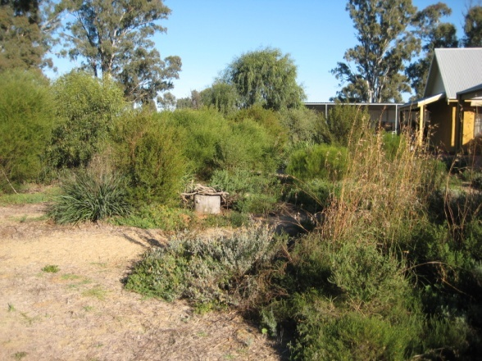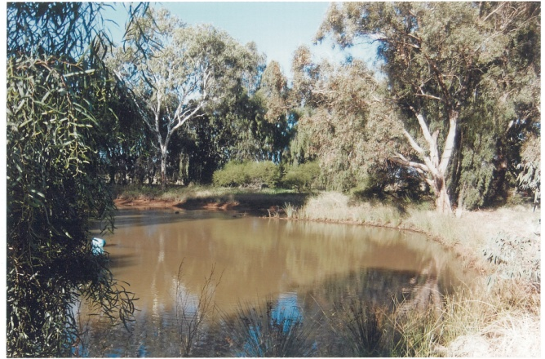
Come and join us on a biodiversity bus tour on
Tuesday June 19th
Spend a relaxing day visiting properties around Griffith learning how to increase the biodiversity benefits of your house garden and create habitat around your sheds. Come along to see Nayce & Helen Dalton’s property ‘Merribee’ and Trevor & Gerardine Hill’s ‘Ingleden Park’ and be inspired. Whether you live on a thousand acres or a tiny town block, this bus trip is for you!
Time: 9.15am to 3.00pm
Where: Join the bus at Murrumbidgee Irrigation, Research Rd Hanwood
Guest Speaker: Cathy Semmler (Environmental Projects, Murrumbidgee Irrigation)
Cost: FREE! Lunch and light refreshments provided
RSVP: Thursday 14th June

Practical  Beautiful  Biodiverse
For more information and to RSVP contact Regional Landcare Facilitator Kimberley Beattie on 0487 953 777 or kbeattie@murrumbidgeelandcare.asn.au

